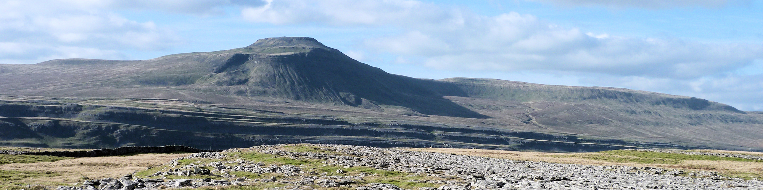
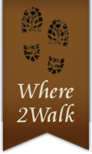

Booking Conditions Where2walk 2017

- How to Book

For Private Parties booking are confirmed on receipt of a deposit and a completed Booking Form. Without both the form and deposit payment there is no contract. If you book less than 30 days prior to the start of the course/holiday full payment must be made to enter in to the contract. Full payment is due 30 days prior to the course/holiday starting. For larger parties individual arrangements can be agreed between both parties.
When you make a booking you will have deemed to have agreed to the following conditions; you and all people on the booking are suitable fit for the activity and acknowledge and accept the hazards and risks associated with outdoor activities (see section 2) and that you or anyone else on the booking do not suffer from any pre-existing medical conditions or disability that may prevent them from actively participating in the activity. It is up to the Group Leader/Organizer to ensure these conditions are met.
U18: Activities, courses and holidays cannot be run/booked for anyone under the age of 18 unless they are accompanied by a parent or appointed responsible adult. Parents are suitably responsible adults must ensure that the children comply with all instructions given and are suitably equipped.

- Acknowledgement of Risk

Your booking is based on your acceptance of the risk inherent in outdoor activities. Our activities take place in a wild environment and may involve hazards including rough terrain, bad weather, water hazards and other people/animals. Whilst we ensure that all activities are as safe as possible, all clients must take sensible precautions to minimise any risk to themselves.
These booking conditions must be passed to all members of the party by the group leader to ensure their full understanding of the risks and responsibilities involved

- Suitability for the activity

It is your responsibility to ensure that you are suitably equipped, adequately fit and experienced to undertake the activity that you are booking. You must inform us in advance of any medical conditions, allergies and/or special requirements, dietary or otherwise that could affect your participation in any activity.
The client accepts that Where2walk and its associates shall not be responsible for loss or damage to property, injury illness or loss of life or consequential damage for any reason whatsoever.
On all self-guided holidays you must be able to read and follow a map (we will send you a 1.25,000 Ordnance Survey map of the route or similar) or in some cases a guide book (also supplied by Where2walk). Any notes supplied in addition are simply to help your route finding and supply substance to the route.
Dogs are also taken at your own risk and we ask you to act responsibly near livestock and keep your dog always under close control.
On guided walks Where2walk will use suitably competent and experienced guides. The decision of the guide will be final on all matters regarding the activity on the day of the walk. The guide reserves the right to exclude any member of the party who goes against the guide’s instructions on the day concerning the safety of the individual and/or party. If any individual creates a nuisance or annoys other members of the party they may also be excluded from the party.

- Insurance

We strongly recommend that you purchase adequate insurance to cover you for your activity. You should note that many travel insurance policies exclude cover for outdoor/sporting activities so do check the details of your own cover very carefully.

- If we Change or Cancel your booking

Whilst we will always do our best to ensure that activities go ahead as advertised, we reserve the right to make any changes to circumstances beyond our control. If we make a change which involves additional expenditure by you have the right to cancel with a full refund.
If we have a course which does not meet the minimum required numbers we have the right to book you on another mutually agreeable course or offer a full refund.
On walking holidays we reserve the right to change an accommodation arrangement that in not under our control ie: an accommodation closes, is found to be unsuitable or has refused to take our booking.
We cannot accept any responsibility for cancellations (at any times) through situations of Force Majeure; war, terrorist attacks, natural disasters, adverse weather conditions, unsuitable conditions or any such conditions outside our control. Even then we will endeavour to find you a suitable alternative date.

- If you change/amend your booking

If you make an amendment to an existing booking (say a date change/name change) we will do our best to help but it may be construed as a cancellation.

- If you cancel your booking

If you wish to cancel your booking for any reason you must inform us in writing (e mail is acceptable). Your date of cancellation is on the date we receive the instruction. Cancellation fees will apply, based on a percentage of the full price and are detailed below:
30 days or more before the start date; retention of deposit
15 to 29 days before the start date; 70 %
14 days or less before the start date; 100%
We strongly advise you to take out appropriate travel insurance, at the time of making the booking to mitigate against any cancellations.

- Baggage Transfers (Holidays)

Your bags will be moved between 9 am and 4.30 pm. We are unable to guarantee the exact time.
The number of bags that you have booked in will be detailed on the itinerary. If you have extra bags to this please let us know prior to travel and you will be charged for them (between £8 to £10 per journey/leg)
Bags should weigh no more than 18 kilos. If our courier deems the bag to be over this weight they will charge for a 2nd bag and the cost will be passed to yourselves.
Bags will be left in secure surroundings or in a place recommended by the accommodation you are staying in. If we are unable to deliver the bag for any reason (ie: bad weather, accommodation supplier not available) we will reunite you with your bag at the earliest possible time.

- Accommodation on your holiday

When we book accommodation on your behalf we act only as your agent. Our responsibility ends when we have confirmed the rooms as requested. We are not involved in the day to day running of any of the properties and therefore not liable for the quality of service received. Any complaints must be addressed to the accommodation proprietors. We have made every effort to establish that the properties we list provide a suitable service. We are pleased to hear about any accommodation that fails to meet appropriate standards of service.

It may not be always possible to put large parties in the same accommodation and may be split. However we will endeavour to limit this as much as possible and attempt to make the second accommodation as close to the first as possible. This is most likely over bank holidays or popular holiday weekends.
Our prices include breakfast unless stated differently on the itinerary. Costs of evening meals (where provided on the premises) are not included in our quotation.

- Your Guide or Instructor (if used)

All bookings are made on the basis that clients will strictly observe any safety instructions given by the guide/instructor. If you choose to ignore the safety instructions given you do so at your own risk.
We reserve the right to change any activity whilst it is underway if, in the guide/instructors judgement this is in the best interest of the group. We also reserve the right to alter an itinerary for any reason that we deem important and will endeavour to inform the customer as soon as possible.

- Complaints

In the unlikely event of any problems or complaint these should be brought to our attention as soon as possible.

- Privacy Policy

We respect your privacy and all personal information is stored in accordance with our privacy policy. No personal information will be passed on for any reason except to those organising your activity.

Where2walk Ltd. Company No 7290625. Long Preston, North Yorkshire BD23 4NJ
Tel: 07824 304060. Email: info@where2walk.co.uk

